Can Australia build its way out of the coronavirus economic slump, with public housing the priority?
ABC Radio National
/
By Peter Mares for Housing the Australian Nation on Earshot
Posted FriFriday 29 MayMay 2020 at 4:30am, updated FriFriday 29 MayMay 2020 at 6:20am
With Australia's remarkable success to date in limiting the health crisis caused by COVID-19, attention is turning to what a recovery from economic impact of the virus might look like.
One strong push is for a significant investment in social housing to help stimulate the economy.
This was an important part of Australia's successful response to the global financial crisis, though the intervention was short-lived. If we want to look for guidance in the role that housing might play in rebuilding, then we'd do better to turn to the more sustained response after World War II.
Aware that their industry is about to stall, Master Builders Australia and the construction union CFMEU have put aside their usual differences to jointly call for the government to spend $10 billion building 30,000 new dwellings.
Housing advocates like National Shelter, Homelessness Australia and the Community Housing Industry Association want the government to build the same number of homes and repair thousands more, and reckon this can be achieved for less than $8 billion.
The Victorian Government has already committed $500 million to social housing as part of its recovery efforts, though most of the funds will go into upgrades rather than new builds.
The fact that the Victorian initiative has been labelled the state's "biggest spend on social housing since the global financial crisis" tells us something: social housing seems to get priority when spending is needed to stimulate the economy and generate jobs.
When property prices are strong, there is little commitment to address the shortage of affordable housing — yet a stable home is the foundation of a good life and a good society. Without a fair and efficient housing system, health, education and productivity all suffer.

The housing crisis
For the past two decades, before the pandemic stopped the real estate market in its tracks, most Australian cities experienced a property boom. The median value of a house has tripled, and grown even more in Sydney and Melbourne.
The rocketing real estate prices had a number of damaging effects. Firstly, it created a mountain of household debt as people took out larger mortgages to buy homes and to invest. A pandemic-hit economy with growing unemployment has exposed the risk that this property debt poses to the financial system.
Secondly, as existing homeowners watched their property wealth grow, some would-be buyers were locked out of the market. As this chart shows, the share of people who own their own home outright has fallen steadily since the mid-1990s, while the share paying off a mortgage has grown, along with the proportion of people renting in the private market.
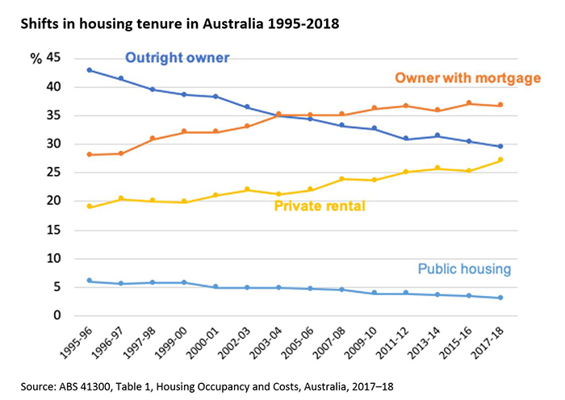
While low interest rates made it easier to pay off a loan, rising prices made it much harder to get the deposit needed to secure a mortgage. According to one calculation, by 2017, it took the average Australian earning average wages 11 years for to save the deposit needed to buy an average house. For the average resident of Sydney, the timeline was more like 40 years.
For many young people seeking to get a foot in the property door, a secure job was not enough. They also needed wealthy parents who could act as the family bank.
Home ownership started to resemble a feudal privilege — something that was only available to those whose families were already members of the property-owning aristocracy — and this had further repercussions, because people who couldn't get into the market were now competing with lower income earners for the same scarce supply of affordable rentals.
As rents rose faster than wages, more and more households were pushed into poverty. They were paying so much to the landlord that there wasn't enough left over for other essentials like heating, transport or food.
As this chart shows, with falling interest rates, housing costs as a proportion of income have remained relatively stable for wealthy Australians (the top quintile), who generally own their own homes, but have increased substantially for Australians on low incomes (the bottom quintile), who are more likely to rent.
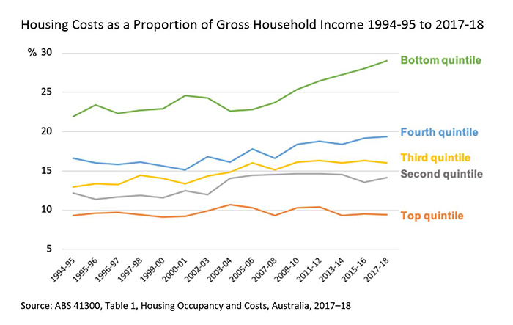
The definition of rental stress is that a poor household pays more than 30 per cent of its disposable income to the landlord.
According to data from both the Productivity Commission and the ABS, more than half of all lower income tenants renting from a private landlord are in stress. This adds up to about 600,000 households, well over a million people, including many children. And evidence shows that families can stay trapped in rental stress for years.
The consequences of a failed housing policy are not just growing inequality and more poverty, but increased welfare costs (the Federal Government now spends $4.4 billion annually on rent assistance alone); poorer educational outcomes, because insecure rentals force families to move frequently and disrupts children's education; and health problems linked to living in overcrowded or poorly maintained dwellings.
So, if housing is to be part of our post-COVID recovery strategy, it needs to be more than a quick fix to help the construction sector through a downturn.
Welcome as it is, Victoria's $500 million stimulus package will only produce 168 new units of social housing. Research by the City Futures Project at UNSW shows there is a short fall of more than 130,000 dwellings state-wide, and that without concerted action, this will grow to 166,000 by 2036.
And there's nothing special about Victoria. The national shortfall in social housing is estimated at 438,000 dwellings and set to grow to 729,000.
In other words, even before the virus, Australia already had a housing crisis, comparable to the situation during WWII.

Re-learning the post-war lessons
In 1943, a year-long commission of inquiry led by legendary public servant H. C. Coombs warned that Australia faced a shortage of 300,000 dwellings.
His report gave rise to the first Commonwealth-State Housing Agreement, ratified just after the end of the war, under which the federal government advanced long-term loans to the states to build rental housing for low-income earners. Over the next 25 years, about one in every six new houses in Australia was built by government.
Coombs' commission of inquiry, and the government action that followed, was partly prompted by a little book called Housing the Australian Nation, which almost 80 years on, provides insights that are remarkably relevant to our current situation.
The authors were two leading social reformers: accountant and lay Methodist preacher, F. W. Barnett and solicitor and company director Walter "Ossie" Burt.
Their argument was based on a simple premise: "It is part of the birthright of every citizen to enjoy decent shelter."
And their primary proposition was that Australia needed a National Housing Scheme, which is what Australia got after World War II.
The book begins with a brief survey of housing conditions around the nation and references the report of a committee appointed by the city council to investigate housing conditions in Hobart, which concluded that "the acuteness of the housing problem lies in the lack of healthy and sanitary houses at a reasonable rent for persons under the basic wage…"
It's a straightforward proposition, which resonates today: low-income earners have a housing problem because there is not enough decent housing that they can afford to rent.
The Hobart committee pointed out that the greatest benefit of improving housing conditions would go to children, and argued that unless housing is addressed, "the benefits of free education and free medical services are seriously retarded…."
In other words, then, as now, a lack of decent, affordable rental accommodation undermines — or overburdens — other aspects of our social system, like universal access to education and healthcare.
The authors argued that providing decent accommodation for those on the lowest incomes, was "a national question that requires a solution which cannot be regarded as a business proposition, but rather as one that is just as necessary as free education and free medical services.".
Again, it seems the insights of 1942 are relevant 78 years later.
We have a political and social consensus in Australia that universal education and universal healthcare are essential goods. There is near unanimous agreement that the state has a responsibility to ensure all citizens enjoy an acceptable standard of education and healthcare regardless of income.
We do not think the same way about housing. Yet housing, healthcare and education are like the three legs of a stool: all are necessary to create the solid basis for a good life.
If people are not adequately housed then other essential goods, like education and health, cannot be assured either. If people are not adequately housed, their potential will be truncated; they cannot flourish as human beings.
"Everyone knows there is a housing shortage," Barnett and Burt wrote 1942.
We can make that statement today, with the qualification that "everyone knows there is an affordable housing shortage".
From this the authors say that two things are obvious.
One, that "private enterprise has been unable to overtake the housing shortage".
And, two: "If the people are so poor that they cannot give private enterprise the financial inducement necessary to build, then the government must come to the financial aid of the people, and in larger measure than ever before being imagined."
The same conclusion can be drawn today. Business is unlikely to solve the current shortage of affordable housing because people on the lowest incomes can't afford to pay rents that generate sufficient profit to give the private sector the incentive to build.

What we need
Large-scale programs to build social housing aren't a short-term fix to help the economy recover from the pandemic, they are a long-term investment in a prosperous and fair society.
It would take a lot of money. But unless we invest in social housing, we are going to spend a lot of money anyway; we're just going to spend in different, less effective ways as we condemn a proportion of the population to housing insecurity and rental stress.
It could cost in terms of increased welfare payments, on visits to emergency departments, on police and ambulance call outs, on putting people through courts and locking them up in jails. We may suffer from lower productivity and lost tax revenue long into the future.
According to economist Saul Eslake, in the post-war decades public sector agencies built more than 15,000 dwellings every year. Today fewer than 4,000 are constructed annually, which is barely enough to replace the number demolished or sold.
In the past, large state housing authorities were responsible for construction and maintenance; today, the same outcomes could be achieved by expanding the not-for-profit community housing sector.
We don't need to return to the same post-war model of social housing, but we would benefit from the same levels of post-war ambition.

Talking straight on COVID-19: the economic effects will be ugly
by Danielle Wood and Brendan Coates

Published in the Australian Financial Review, March 18 2020
In a crisis the public wants straight-talking. The unvarnished truth is that the economic effects of COVID-19 and the associated public health response will be enormous.
Recession is practically inevitable. But the right government response can minimise the damage a sharp contraction this year will have on the Australian economy in the long term.
There will be multiple COVID-19 shocks. The first is the supply shock. Over the next few months many businesses will be hit by a reduction in supply of imports, particularly manufactured goods from China. Supply-side problems will become widespread as workers take time off because they are sick or required to follow ‘social distancing’ rules.
But this will be dwarfed for many businesses by the shock to demand from the public health response. If we want to avoid significant death rates among the most vulnerable, we will need to slow the spread of the virus. Australians should expect that childcare centres, schools and many workplaces will be shut down for a period.
The economic costs will be large. ‘Social consumption’ – going for brunch, attending a football game, getting a haircut – will dry up for several months. Businesses in the accommodation and food services, tourism, arts and recreation, and retail services will take a significant hit to their cash flows. Casual work in these sectors will slow to a trickle.
Initial work from Warwick McKibbin at ANU suggests a global pandemic like the one now unfolding would see Australian GDP fall by between 3 and 5 per cent in 2020. That would plunge Australia into its deepest recession since the early 1980s, if not the 1930s.
An economic hit of this magnitude also presents big risks to financial stability. Firms and households face a liquidity crunch as incomes take a hit. Banks will see an increase in non-performing loans. Australia’s high level of household debt exacerbates these risks.
This suggests two priorities for the fiscal response.
First is ensuring that otherwise sound businesses are able to survive the short-term hit to their cash flows. Support would reduce the threat to financial stability from widespread default as well as to avoid long-term damage to the productive capacity of the economy.
Second is making sure households have enough cash flow to cover their necessities – rent or mortgage, bills etc – during a period when many will take a hit to their incomes.
About 25 per cent of Australian employees do not have access to paid leave entitlements and those that do may not have enough. And more than 10 per cent of workers are self-employed and therefore have no paid sick leave.
Millions of workers could be out of pocket if there is widespread closure of schools and workplaces. Making sure that all workers have a safety net is part public health response (making sure the sick can afford to self-isolate) and part economic (limiting personal hardship and ultimately financial system risk from a household liquidity squeeze).
But those calling for spending to stimulate demand and investment today are still fighting the last economic war. While these were the first line of defence during the confidence crunch of the GFC, they are less important today when spending is constrained by public health restrictions. Such measures will make a lot more sense on the other side of the infection curve when we are trying to get the economy moving again.
So how does the response to date measure up?
The business side of the government’s first package gets points for both its size and its focus on giving business some cash flow breathing space. The $25,000 income tax write-off for businesses with turnover of less than $50 million is effectively a cash bonus for all small and medium businesses with staff.
The wage subsidy for apprentices should provide an incentive for businesses to keep on their younger workers, those that are otherwise most vulnerable to losing their jobs in a downturn.
But much more will be needed for households. The first package focused on demand stimulus through cash payments to people who receive government payments. It’s hard to argue with giving people on Newstart a lifeline (and they certainly will spend it), but the package largely missed the main target: the ‘affected worker problem’.
The only part of the package that supports cash flow for affected workers is the proposal to abolish the waiting period for the taxpayer-funded Sickness Allowance. But many workers would face a long wait for payments: the average wait today is about 35 days and this will only rise as the number of claims grows. And even with this support many will struggle to pay the bills given that payment is the same as the Newstart allowance.
Payments to households via the personal income tax system (with some means test) are the easiest and quickest way to ensure that working households are able to cope with a hit to their incomes. Fast-tracking early access to superannuation or offering HECS style loans to workers would also help.
A straight-talking and straight-thinking government would deliver these as the centrepiece of a second stimulus package as soon as possible.

Experts on how coronavirus will wallop Australia's economy – and what the government must do
Stephen Koukoulas, John Quiggin, Danielle Wood Gigi Foster, Stephen Kirchner and Sally Auld
This article is more than 4 months old
Economists say a recession is now nearly inevitable. The only question is how long it will last
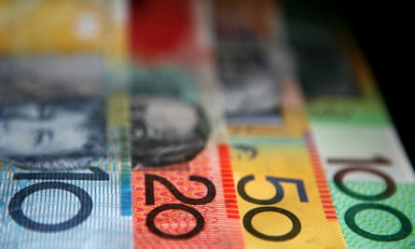
In coronavirus-hit Australia, cash handouts would be ‘both an economic and a public health measure’, one expert says. Photograph: Bloomberg/Bloomberg via Getty Images
Published onWed 11 Mar 2020 12.07 AEDT

98

763

Pain can be avoided with a $5bn injection each quarter
Australia’s economy will be driven as much by the policy response to the coronavirus as the fallout from the coronavirus itself.
The substantial negative impact on global trade, investment, household spending and employmentwill spark a deep and probably protracted recession in Australia if unchecked by policy innovation from the Morrison government. Unemployment approaching 7%, deflationary pressures and fresh record lows for wages growth will be the key aspects of such an economic slump.
Most if not all of this pain and hardship can be avoided. If the government outlines a plan to inject at least $5bn a quarter directly into the economy, these negative influences can be partially, perhaps fully, offset.

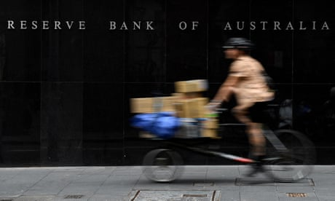
RBA deputy governor says Australian government's stimulus package 'will provide welcome support'
Read more

Fiscal stimulus of this order, directed to the household sector, would add about 1% a quarter to nominal GDP in the first instance. If the crisis lingers, the stimulus can be scaled up.
It is not clear whether the government is prepared to deliver such as stimulus, mainly for reasons of ideology.
If the fiscal package is anything less, the economy will remain very weak, unemployment will rise by around 1 percentage point by the end of 2020 and wages growth and underlying inflation will fall to fresh record lows.
- Stephen Koukoulas is the managing director of Market Economics

The government has finally recognised the correctness of the Rudd government’s response to the GFC
The Australian economy was slowing even before the bushfire catastrophe and the arrival of coronavirus. The economic costs of the bushfires, including damage to property and infrastructure, long-term health effects of smoke exposure and ecosystem destruction were massive, but the main effects on GDP will be felt by the tourism sector. The damage to Australia’s international image from widespread vision of the fires, accompanied by critical commentary to the effect that, as a climate laggard, we have brought this on ourselves, will be long-lasting.
The arrival of the coronavirus, just as the last bushfires were extinguished will have a greater short term impact on economic activity, almost certainly resulting in two or more quarters of negative growth. With an underlying growth rate of 0.5% per quarter, a 5% contraction in the 10% of the economy most exposed to the effects of coronavirus would be sufficient to reduce growth to zero.
It appears that the government has finally recognised the correctness of the Rudd government’s response to the GFC, and will follow that path, with some marginal attempts at product differentiation. It is likely that the effect on the budget balance will be substantially greater than the $10bn currently being discussed, and that the recent decline in the ratio of public debt to GDP will be reversed. In these circumstances, the massive tax cuts for high income earners, legislated for 2024-25 will probably prove unaffordable.
- Professor John Quiggin, VC Senior Research Fellow, school of economics, University of Queensland

Recession is nearly inevitable. The question is how deep it will be
It’s hard to look at the health data on Covid-19 without serious trepidation about the economic effects. The first wave – the contraction in travel-exposed sectors such as higher education and tourism – has already arrived. Treasury and the RBA estimate the impact on these two sectors alone will wipe 0.5% off GDP this quarter.
The second wave could be much bigger. If we want to avoid significant death rates among the vulnerable, we will need to take strong measures to contain the spread. As we’ve seen in China and South Korea, doing this effectively means shutting down childcare centres, schools and many workplaces for a period.
This will be a big hit to business activity and consumer spending. Recession is nearly inevitable. The question now is how deep it will be, and how long it will last.
The No 1 priority for economic stimulus in the short term is to shore up cash flow for businesses during the crunch period. We must avoid causing otherwise viable businesses to hit the wall. Tax deferrals, interest-free loans and cash payments should all be on the table.
The No 2 priority is to get cash into the hands of households in the event of containment. This is more than just a demand-response measure – it’s about ensuring that working Australians, almost 25% of whom are casual and do not have access to paid leave entitlements, are able to survive during a sustained period off work, either because they are showing symptoms, their workplace is closed or their children are at home. While Scott Morrison would prefer businesses to pay, not all will, and we must ensure that no exposed worker avoids going into isolation because they fear they can’t afford it. In these circumstances, cash handouts are both an economic and a public health measure.
- Danielle Wood, is program director, budget policy and institutional reform, at the Grattan Institute

Australians are ready to spend
The uncertainty surrounding the severity and hence ultimate economic impact of the Covid-19 virus is the most challenging feature of the virus phenomenon from the perspective of government policy-setting.
This is not a “normal” entry to an economic downturn: we are not seeing the start of a collapse of a bubble between market fundamentals and lofty expectations that weakens aggregate demand. Most Australians today are ready to spend (for example, on toilet paper!), but global supply chains are being disrupted in uncertain ways, and that uncertainty will take months to resolve.
In the meantime our government should work against public panic via transparent, practical stewardship, emphasising our excellent public health system and border controls, and promoting guidelines around personal hygiene and sensible decisions for vulnerable groups (such as the elderly) that have a clear connection to harm minimisation. The government should emphasise what we do have certainty about: eg hand-washing works (we may even see a short-run uptick in productivity and schooling outcomes due to better personal hygiene), and this virus is unlikely to seriously affect most healthy people who contract it.
Short-term targeted assistance to heavily affected industries, like airlines and tourism, should also be on the agenda.
- Gigi Foster is a professor in the School of Economics at the University of NSW, and co-host with Peter Martin of the Economists on ABC RN.

There is no substitute for decisive action by monetary policy
It will be difficult for Australia to avoid recession in the first half of 2020, with the Covid-19 shock hitting an already soft economy.
The government is looking to implement a circa $10bn fiscal package. Measures designed to directly address the incipient pandemic and its immediate consequences are obviously needed. As the global downturn deepens, the federal budget will go into deficit even in the absence of new policy decisions.
However, there is no substitute for decisive action by monetary policy. As I argue in this report on lessons from the US experience with quantitative easing, low interest rates are not a constraint on the effectiveness of monetary policy. Unlike fiscal policy, monetary policy is quickly and infinitely scalable. Monetary stimulus is relatively costless to implement and can be unwound quickly when no longer needed.

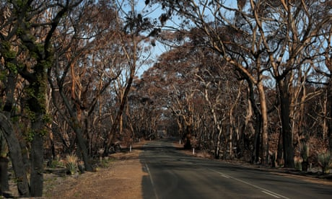
Money set aside for bushfire recovery may be used for coronavirus response
Read more

In Australia, some have argued the government has been slow to respond, but this fundamentally misunderstands the division of macroeconomic responsibility in an economy with a floating exchange rate and inflation-targeting central bank.
The government’s real mistake was to give the RBA board a licence to neglect its singular responsibility for demand management and then squib the opportunity to rein in that licence and hold the RBA more accountable.
- Stephen Kirchner is program director, trade and investment, at the United States studies centre, University of Sydney

Effective fiscal policy could see improved performance by 2021
The Australian economy is likely to experience a very weak first half. In the first quarter, this will be reflected in weaker goods and services exports due to travel bans and slower growth in China. The impact of the bushfires will also be a drag on growth in first three months of the year.
In the second quarter, economic weakness is likely to emanate from materially lower rates of household consumption growth, as disruption associated with Covid-19 constrains spending. And because household consumption accounts for almost 60% of GDP, when spending slows, so does GDP growth.
But looking beyond the first half of 2020, we expect that the economy should improve in the second half of 2020, as Covid-19 infection rates peak, global growth improves and monetary and fiscal stimulus take effect.
The government’s use of fiscal policy should play a critical role on two fronts: insulating the economy from the demand shock taking hold; and ensuring that firms and financial intermediaries can act to minimise disruption to both labour and credit markets. If it is successful on both fronts, then economic damage will be contained and the economy will be poised for a much-improved performance in 2021.
– Sally Auld is head of Australia and New Zealand economics and markets research at JP Morgan

The curse of ‘The Lucky Country’: In search of economic antidotes to COVID-19
May 4, 2020 | Article
By Jenny Child, Thomas Rüdiger Smith, and Joseph Tesvic
Open interactive popup
The curse of ‘The Lucky Country’: In search of economic antidotes to COVID-19
Open interactive popup
Australia’s experience with a global pandemic, like in most countries around the world, is unprecedented.

DOWNLOADS
Open interactive popup
Article (PDF-798KB)
Australian consumers and businesses are faced with a triple whammy:
- a significant and evolving public-health threat
- severe, regulated restrictions on movement and everyday freedoms
- rapid and deep financial pressures
The human tragedy and the knock-on economic effects of the COVID-19 crisis have sparked intense emotions. The past few months have triggered fear and uncertainty in even the most rational Australians. In McKinsey’s weekly sentiment polling, the majority of respondents say they are very or extremely concerned with all strands of the COVID-19 situation—from the economy to their health to the length of the shutdown (and these figures are increasing each week) (Exhibit 1). This has coalesced into an arresting statistic: almost 80 percent of Australians say they are unsure or pessimistic about the country’s economic recovery.
Exhibit 1

We strive to provide individuals with disabilities equal access to our website. If you would like information about this content we will be happy to work with you. Please email us at: McKinsey_Website_Accessibility@mckinsey.com
On the one hand, this sentiment is expected and understandable, particularly for those who have suddenly become unemployed, or fear that they will. Forty percent of Australian households report a reduction in their household income, driven by household members’ loss of full-time or part-time work. At the time of this writing, modeling from Australia’s Department of the Treasury projects a 10 percent unemployment rate, or 1.4 million unemployed Australians by the end of the second quarter.
The fears and emotions stirred by the virus outbreak translate into real economic impact when they change how Australian consumers spend their money (Exhibit 2). For example, across all categories (outside groceries, household supplies, and in-home entertainment), net intent on spending over the next two weeks is down by big double digits.
Exhibit 2

We strive to provide individuals with disabilities equal access to our website. If you would like information about this content we will be happy to work with you. Please email us at: McKinsey_Website_Accessibility@mckinsey.com
It’s no surprise that Gen Z and millennials—who have been disproportionately affected by income loss to date—are the most worried about the economy and are tightening their belts accordingly. Our figures show that 63 percent of Gen Z reports “cutting back on spending,” compared with 30 percent of baby boomers, or 45 percent of Australians in total.
No matter what demographic you sit in, it is important to keep a close eye on the younger generation. Millennials and Gen Z already comprise 40 percent of the Australian population. So how these generations are feeling and behaving matters materially for the country’s economy and society.
But before accepting that Australian consumer sentiment matches the current “very or extremely concerned” scenario, a few other facts offer a striking contrast.
First, there is the nation’s success in dealing with the health crisis. Australia has so far been able to control the spread of the coronavirus and ranks among the group of nations with the lowest infection and fatality rates worldwide (Exhibit 3).
Exhibit 3

We strive to provide individuals with disabilities equal access to our website. If you would like information about this content we will be happy to work with you. Please email us at: McKinsey_Website_Accessibility@mckinsey.com
Second, at a striking 17.7 percent of GDP, the amount of economic aid from the Australian government has outpaced every other comparable country in the world except the United Kingdom and Germany (Exhibit 4).
Exhibit 4

We strive to provide individuals with disabilities equal access to our website. If you would like information about this content we will be happy to work with you. Please email us at: McKinsey_Website_Accessibility@mckinsey.com
Australia is not out of the woods, of course. But the response of the Australian people (with a little initial prodding), combined with the action of the government, has moved the country closer and closer to a manageable “R nought figure” (the reproductive ratio of the virus), which is a significant accomplishment any way you look at it.
With these facts in mind, let’s revisit consumer sentiment. Australians, compared with the citizens of 14 other nations, lean to pessimism about the economy. Despite being a leader in battling COVID-19 itself, Australia ranks in the middle of the pack in optimism about recovery from it (Exhibit 5).
Exhibit 5

We strive to provide individuals with disabilities equal access to our website. If you would like information about this content we will be happy to work with you. Please email us at: McKinsey_Website_Accessibility@mckinsey.com
Perhaps most shockingly, Australians are half as optimistic as citizens of the United States, where more than 68,000 people have died from COVID-19 (as of May 4, 2020), and less than half as optimistic as Chinese citizens.

MOST POPULAR INSIGHTS
- COVID-19: Implications for business
- ‘True Gen’: Generation Z and its implications for companies
- Ready, set, go: Reinventing the organization for speed in the post-COVID-19 era
- Consumer sentiment and behavior continue to reflect the uncertainty of the COVID-19 crisis
- Reimagining the office and work life after COVID-19
This negative outlook is reflected locally in the Westpac Consumer Confidence Index, which stands at 75.6 points, a mere 0.1 point from early-1980s recession levels—levels which, it should be noted, were hit in the depths of those recessions, not at the outset of them.
We are struck by this juxtaposition. And, it has prompted us to start a deeper exploration of Australians’ beliefs, attitudes, and behaviors, which ultimately underpin the economy. We think that this exploration is important to ensure that the population’s concerns do not unduly weigh down the country’s capacity not only to recover but also to innovate and prosper after the crisis.
After all, we are the economy. Former UK Prime Minister Margaret Thatcher famously noted, when pondering the concept of society, that governments can only do things through people, and we all have roles and responsibilities to play. The responsibly on all of us in a time of fear is to strive to remain reasonable and objective. When you consider that, on a global scale, Australia’s burden seems light, and the fundamentals that have driven our prosperity remain.
With that in mind, over the coming weeks, we will explore and attempt to answer the following questions:
- How is COVID-19 changing us as people and as consumers?
- Has COVID-19 exposed a lack of resilience in “The Lucky Country”?
- How will a changed hierarchy of needs and priorities shift what matters to us and therefore what we buy, how we buy it, and what we are willing to pay for it?
- Are Gen Z and millennials right to believe they will be the most significantly affected by COVID-19’s economic aftershocks, and what can be done to ease their fears?
- How can B2C businesses adapt and innovate to meet the post-COVID-19 consumer where they are?
The seriousness of Australia’s COVID-19 challenge notwithstanding, we believe there is not only a light in our economic tunnel, there are many.

